Bridging the Gap: Unraveling the Connection Divide in the Digital Age

Tracy Harvey

SOC319 – Sociology of the Digital World

**Introduction**

In our technology driven world there is a story that has the potential to be both transformative and disruptive to society on our planet. In the digital age it seems like we, humanity, are constantly interconnected, constantly having the collective knowledge of the world at the tips of our fingers. Well, some of us do at least, because hidden in this seemingly perfect information golden age is a dark challenge – the digital divide. As we stand here at the crossroads of innovation and inequality there is a critical facet of the digital divide that demands our attention: the connection divide.

As a central theme in the larger conversation on digital inequalities, the connection divide draws our attention to the unequal distribution of internet connectivity and access which shapes the participation in the digital realms. It is a divide that permeates not just the physical infrastructure of cables and signals but also into the fields of everyday social engagement, employment, health care, and education. To understand the complexity involved in the connection divide, this study will investigate the core of this digital gap.

We shall examine the contributing factors, regional variations, and socio-economic consequences of the connection divide. The main objective as we navigate this environment is to promote an understanding of digital inclusion where all the benefits of this marvelous digital age can be shared across all geographic and socio-economic divides.

**Digital Divide in a nutshell**

What is the digital divide? According to dictionary.com the digital divide is “the socioeconomic and other disparities between those people who have the opportunities and skills enabling them to benefit from digital resources, especially the internet, and those who do not have these opportunities or skills” (*Dictionary.Com | Meanings & Definitions of English Words*, 2023). Now this sounds like a very cut and dry topic as in there are the haves and the have nots, but it is not really that simple. In an article posted on internetsociety.org Charlie Muller states that the digital divide is not one piece but that “the digital divide is multifaceted and includes many factors such as access, affordability, quality and relevance” (Muller, 2022). The understanding of this multifaceted nature is very important to addressing the root causes of the digital divide.

**A problem of connection**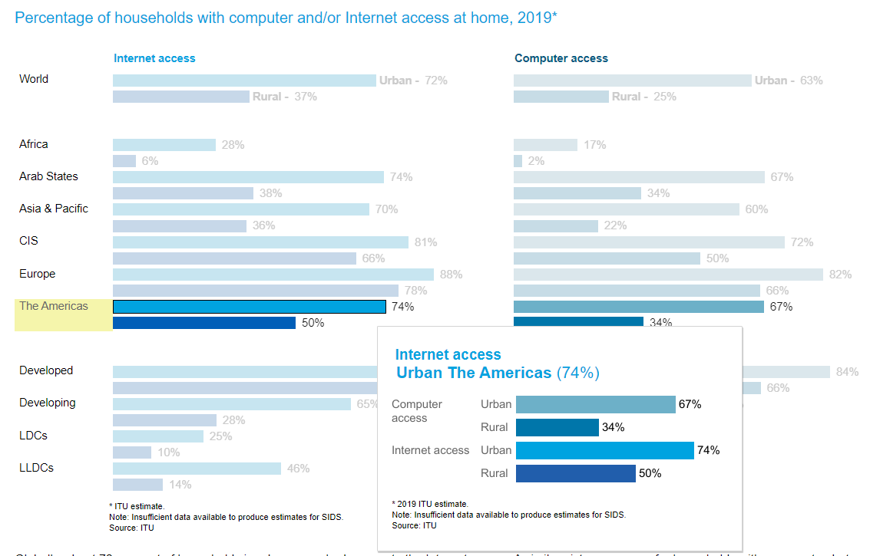

Figure 1

Source: [*https://public.tableau.com/profile/ituint#!/vizhome/ITUFactsandFigures2020/ITU2020*](https://public.tableau.com/profile/ituint#!/vizhome/ITUFactsandFigures2020/ITU2020)

Muller’s characterization of the digital divide being multifaceted was particularly insightful. One of the fundamental issues in the digital divide is actual physical access to the internet. According to statistics found on public.tableau.com outlining the internet and computer access at home for many countries around the world. Internet access in the Americas is seventy four percent in urban areas and is only fifty percent in rural areas. (*ITU Facts and Figures 2020 - Measuring Digital Development - #Internet #ITU*, 2020) This difference of twenty four percent probably does not seem like much but it translates into a significant gap in educational, job, health care, and even recreational opportunities and resources. The disparity in access to the internet between urban and rural areas only highlights the spatial aspect of the connection divide where geographic location significantly influences people’s digital experiences and opportunities. In an article published on the website for the national library of medicine named The Digital Divide is a Human Rights Issues: Advancing Social Inclusion Through Social Work Advocacy Federal Communications Commission (FCC) reports as of 2019 said “an estimated 21 million Americans still have no home access to high-speed internet service” (Sanders & Scanlon, 2021) and the article goes on to say that this data is “likely an underestimate of the number of people who do not have access to broadband, as the FCC’s data is widely considered to overestimate this number” (Sanders & Scanlon, 2021). Even if you are in a location where you are physically able to get access to the internet, another formidable roadblock that perpetuates the connection divide is the cost of that access. An article on pewtrusts.org by Joyce Winslow reports that “The Pew Research Center reported in May that 44 percent of adults in households with incomes below #30,000 don’t have broadband” (Winslow, 2019) and to shed some light on that I did a little research into what internet access costs here in Washington state and other places. According to a website called InMyArea.com The average cost is around $78.43 which according to the website puts Washington at “42nd in the nation” (*Washington Broadband Availability, Speed, Providers - In My Area*, n.d.) and to look in another state another article called Bridging the digital divide: Wi-fi Hot Spots as a Means of Digital Equality says that In 2019 in Montana “The average cost of internet per month is $91.54 (third highest in the nation)” (Salsbury & Hansen, 2022). These comparisons emphasize the variability across the nation, with prices fluctuating all the time, making the price for internet in Montana potentially considerably higher now in 2023. The vast differences in the cost of internet from state to state and region to region underscore the massive impact on digital equality. Low-income households today not only face challenges in accessing the internet but also in affording the essential connectivity that has become an essential part of everyday life from education and employment to healthcare and civic engagement.

The data in Figure 1 also contains the statistical differences between urban and rural areas when in the context of computer access but the report on public.tableau.com says that because computers are no longer the primary gateway to the internet the percentage of households with a computer will be smaller but goes on to point out that the urban to rural gap is significantly larger in this area than in internet access (*ITU Facts and Figures 2020 - Measuring Digital Development - #Internet #ITU*, 2020) which leads into the next issue of the connection divide: computer access.

Computer access is a much more straightforward problem of cost, but to a family on or below the poverty line that can spell the difference between having internet access and not having it. In the before mentioned article The Digital Divide is a Human Rights issue states that “lower-income adults rely more heavily on smartphone-only access” (Sanders & Scanlon, 2021) and it goes on to say that “26% of adults making $30,000 or less relied on smartphones for internet access” (Sanders & Scanlon, 2021). Things that are taken for granted in the digital age banking, online shopping, job applications and even schoolwork get more complicated when the only internet access is a smart phone.

**Addressing the issues**

There are a plethora of ways government agencies, businesses, non-profit organizations, and even individual private citizens have stepped in and undertaken initiatives to address the connection divide. Policy makers are stepping in and creating new partnerships with private companies to entice them to step in and plug the internet service gaps in the rural areas where the larger companies do not want to go, through grants and such or stepping in beside people in rural areas and assisting them in paying for high-speed internet to be installed as stated in the article America’s Digital Divide “In Indiana, large-scale farmers have paid to bring broadband to their farms – often with help from seed manufactures and data management companies” (Winslow, 2019). Organizations such as Montana State University (MSU) have written grant proposals “to purchase Wi-fi hot spots for the 2020-21 academic year to collect data on access needs for MSU students” (Salsbury & Hansen, 2022). There are federally funded programs such as the Emergency Broadband Benefit Program that was established to “help families and households struggling to afford internet service during the COVID-19 pandemic” (*Emergency Broadband Benefit | Federal Communications Commission*, n.d.)

Like internet access solutions there are various federal, state, and local government programs out there to assist low-income families to get computer hardware that they need. E-waste recycling programs that refurbish older hardware and then sell that hardware either very cheaply or give it to families that are in need of a computer such as PCsForPeople.org. or Non-profit organizations such as computers with causes which provide computer resources to families in need.

**How my own actions contribute or resist inequalities/inequities.**

I would love to believe that my own actions do not contribute to inequalities/inequities especially those of the connection divide, but I have seen a bit too much to be that naive. Though from where I come from and my background, I often forget things like the digital divide exist. So, I guess I would say that I contribute by pure blindness to the issue. I personally cannot imagine being a student of any age and having to do schoolwork on a phone because it is my only computing resource or internet source. Researching this paper on a phone would have been a nightmare.

That being said, my friends and I are avid video gamers, so we replace our computer components or whole computers fairly often. Recently we have been paying attention to the amount of e-waste that gets thrown in landfills and instead of throwing our computers away we have been refurbishing them and giving them to friends and family. Which is a good start, but in researching this paper I believe that we could do more by locating non-profits or organizations that need the hardware to give to others.

**Conclusion**

To sum up, the journey toward closing the digital divide is a constant process. For this to actually bear fruit it will take dedication from all levels of society to understand the obstacles and actively choose to close the divide. Bridging the connection divide is not only a technological need but also a societal duty. Every effort taken regardless of if it is from a governmental policy level, or an individual level contributes to the shift in the narrative in favor of equality, accessibility, and shared opportunity.

**References:**

Aguiar, C. M., João Paulo de Vasconcelos. (2022, March 3). What Is the Digital Divide? *Internet Society*. <https://www.internetsociety.org/blog/2022/03/what-is-the-digital-divide/>

*Dictionary.com | Meanings & Definitions of English Words*. (2023, November 30). Dictionary.Com. <https://www.dictionary.com/browse/digital%20divide>

*Emergency Broadband Benefit | Federal Communications Commission*. (n.d.). Retrieved December 1, 2023, from <https://www.fcc.gov/broadbandbenefit>

International, T. U. (2020). *ITU Facts and Figures 2020—Measuring digital development—#Internet #ITU*. Tableau Software. <https://public.tableau.com/views/ITUFactsandFigures2020/ITU2020?%3Adisplay_static_image=y&%3AbootstrapWhenNotified=true&%3Aembed=true&%3Alanguage=en-US&:embed=y&:showVizHome=n&:apiID=host0#navType=2&navSrc=Parse>

Salsbury, M., & Hansen, M. A. (2022). Bridging the Digital Divide: Wi-Fi Hot Spots as a Means of Digital Equity. *Portal : Libraries and the Academy*, *22*(1), 199–219.

Sanders, C. K., & Scanlon, E. (2021). The Digital Divide Is a Human Rights Issue: Advancing Social Inclusion Through Social Work Advocacy. *Journal of Human Rights and Social Work*, *6*(2), 130–143. <https://doi.org/10.1007/s41134-020-00147-9>

*Washington Broadband Availability, Speed, Providers—In My Area*. (n.d.). InMyArea.Com. Retrieved December 1, 2023, from <https://www.inmyarea.com/internet/washington>

Winslow, J. (2019, July 26). *America’s Digital Divide*. Pew. <https://pew.org/35A4Wlj>